Young Friends General Meeting
YOUNG ADULT QUAKERS IN BRITAIN
Documents in Advance Part I

Information & Practicalities
Young Friends General Meeting 23rd - 25th February 2024
This information & practicalities document provides information about YFGM’s February 2024 gathering, which will be held at York Quaker Meeting House.
Table of Contents
Information & Practicalities 1
Before YFGM: 2
The Meeting House. 2
Newcomers 3
Accessibility 3
What do I need to bring? 3
During YFGM: 4
Sleeping Arrangements 4
Cooking, cleaning, & sharing a space 4
Nominations 4
YFGM TIMETABLE 6
Explanation of Sessions 11
Meeting for Worship 11
Epilogue 11
Meeting for Worship for Business 12
Special Interest Groups (SIGs) 12
Entertainments (Ents) 13
Big Notices! 13

Before YFGM:
Join the YFGM Discord server to chat to other YFGMers and ask any questions: NEW Official Discord https://discord.com/invite/UNjHwQh8CQ
If you have access needs or practical concerns please email logistics@youngfriends.org.uk; for questions about the agenda or business, get in touch with clerks@youngfriends.org.uk.

The Meeting House
YFGM is being held at York Quaker Meeting House. The address is: Friargate Quaker Meeting house, Friargate, York. YO1 9RL.

The nearest train station is York, 0.8 miles from the Meeting House (approximately a 19 minute walk). The nearest bus station, Low Ousegate, is 150m away (approximately a two minute walk).

If travelling by car the nearest car park is Castle car park, approximately 150m away

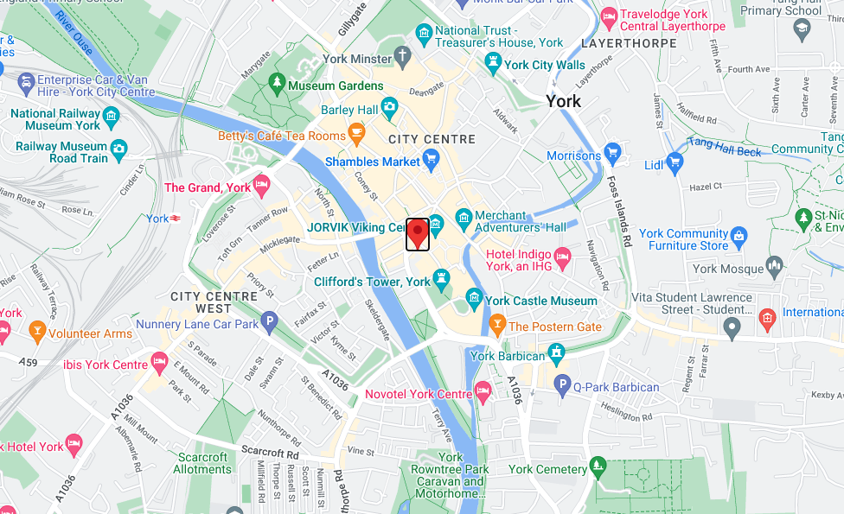

Arrivals
On Friday, we begin with Opening Worship at 7pm (although some YFGMers will be at the Meeting House earlier helping with set up or cooking). If possible, please arrive in time for the opening session at 8:30pm, which will include an introduction to YFGM and essential notices.

Although some YFGMers will be at the Meeting House earlier, helping to set up, it’s generally helpful to arrive no earlier than 6pm.

Newcomers
If it’s your first time at YFGM (or you haven’t been in a while, or you simply feel new) then you can request to join the YFGM Newcomer WhatsApp Group, run by the pastoral committee. The chat is to allow Friends to ask questions about what to expect at YFGM and learn a little about how YFGM functions. Some members of our Pastoral and Eldership committees will be in the group to answer any questions you may have. For any sign-up requests please email pastoral@youngfriends.org.uk with the subject line “newcomer”.
During the weekend, there will be three newcomers sessions. These are option sessions that you can come along to, to help get to know each other and answer questions.

Accessibility
Making our events as accessible as possible is a priority for us. If you have any access needs that you feel YFGM needs to be aware of, or any queries about accessibility, please mention it in your registration or email logistics@youngfriends.org.uk.
At Friargate Meeting House there is lift access to all floors, with accessible toilets on the ground floor. A hearing loop is installed in the main meeting room.

What do I need to bring?
A weekend’s worth of clothes, toiletries, medication, and any other personal items you need. If sleeping in the Meeting House a sleeping bag and pillow, plus we recommend a mat or air mattress for comfort.

You don’t need to bring any food or drink with you, as we’ll cook and eat together; however, if you do bring additional snacks, please do not bring any nuts (or shellfish!) due to allergies.

On Saturday evening we will be having an open mic night (music, poetry, interpretive dance, etc) and a book swap/book club. Bring along any books you no longer need and/or anything you might need to dazzle us with your talents during the open mic night!

During YFGM:

Sleeping Arrangements
There will be a number of separate sleeping areas designated during the weekend. Each room will have a set “lights out” time - at least one each of 11pm, midnight, and late (no specific time).

For those who require off-site accommodation (i.e. a bed), there are plenty of hotels in York including a nearby Travelodge. If you need support with the cost of this, our accessibility and bursary policy may be relevant - contact treasurer@youngfriends.org.uk for more information.

Bag rooms
During the day, a room will be designated as a ‘bag room’. Please make sure that you put your bags (and sleeping bags, shoes, air mattresses etc.) away in this room during the daytime, to keep other rooms tidy and accessible.

Cooking, cleaning, & sharing a space
For the duration of a weekend, we form a short-lived intentional community; we share a living space. As part of keeping that space usable, you will be asked to help out with the cooking for one or two meals; with the clear-up for some other meals, and to help out with tidying the meeting house on Sunday.

Please look out for other opportunities to help out. If furniture needs rearranging, or if the washing up is taking longer than expected, then please lend a hand - it will make everybody’s YFGM more pleasant.

We also take turns minding the door to the meeting house, to make sure that new arrivals are welcomed and that curious passers-by are greeted. You can sign up for the doorkeeper rota when you arrive; please sign up for one or two sessions so that the work is fairly shared out.

Eating together
The meals at YFGM will be vegetarian or vegan, with vegan options available. Please let us know about allergies or intolerances when you register, so that we can make sure suitable options are provided when putting together the menu. We’ll aim to include the planned menu in Docs in Advance Part II, but these may be subject to change at short notice.

Nominations
As a Quaker organisation, YFGM uses the Quaker nominations process to find people to fill volunteer roles within the Meeting. Nominations are a key part of Quaker process, and while much of it takes place behind closed doors, it is central to the life of any Meeting.
We ask our whole community to make suggestions for people they think might fill particular roles. This is very valuable, since we are a large enough community that a small group can’t possibly know everyone well.
YFGM nominations committee will approach people who have been suggested during or in the run up to the next YFGM event to find out if they are willing and able to be in the role or roles their name has been suggested for. They will discern, using the Quaker business method, who is right for a given role at a given time, and bring that forward to the Meeting for appointment. You are very welcome to suggest your own name.
Almost every role within YFGM is appointed following a nomination by the Nominations Committee - the big exception is the Nominations Committee itself. While the key work of discernment is done by the Nominations Committee, the whole Meeting is responsible for nominations and needs to support the committee by upholding them, by making suggestions, and by considering approaches with a frank and open mind.

This YFGM gathering we will be nominating roles including:
- Planning Weekend Newcomer: Someone who hasn’t previously attended a YFGM planning weekend, who attends, feeds in, and provides a report to YFGM on their experience.
- Logistics Committee: Ensure the smooth running of YFGM events, dealing with practicalities and delegating tasks to YFGMers (as a committee of 5 people).
- Elders Committee: Our elders care for the spiritual health of YFGM; facilitate worship, meeting for worship for business, and spirituality sessions; and facilitate threshing sessions at planning weekend (as a committee of 5 people)
Please go to the YFGM website https://yfgm.quaker.org.uk/ for details on roles and the nominations process, and to submit your nominations. At YFGM, please find a Friend on the Nominations Committee or use the submissions box that will be advertised.

YFGM TIMETABLE
Friday

18:00 - 19:00 | Arrivals
19:00 - 19:30 | Opening Worship
19:30 - 21:30 | Evening mealtime, including:
 | Introduction & welcome session
 | Newcomers’ welcome session
21:30 - 22:00 | Epilogue (evening worship)

Saturday

08:30 - 09:45 | Breakfast
09:45 - 10:00 | Welcome session
10:00 - 11:00 | Meeting for Worship for Business, including:
 | Introduction to Quaker Business Method
 | Introduction to Nominations Required
 | Reports from Planning Weekend Newcomers, Trustees, etc.
11:00 - 11:15 | Break
11:15 - 12:15 | Spirituality session
12:15 - 12:30 | Break
12:30 - 13:45 | Palestine: Practical action for peace
13:45 - 15:00 | Lunchtime
15:00 - 16:00 | Community Time
16:00 - 17:00 | Special Interest Groups
17:00 - 17:15 | Break
17:15 - 18:30 | Meeting for Worship for Business, including:
 | Further reports as needed
 | Discernment on Palestine
18:30 - 20:00 | Evening mealtime, including:
 | Big Notices!
20:00 - 21:15 | Entertainments
21:15 - 21:30 | Break
21:30 - 22:00 | Epilogue

Sunday

08:00 - 09:15 | Breakfast
09:15 - 10:00 | Cleaning the meeting house
10:00 - 10:30 | Preparation for Meeting for Worship
10:30 - 11:30 | Meeting for Worship (with local Friends)
11:30 - 12:00 | Notices & chat with local friends / Break
12:00 - 14:00 | Meeting for Worship for Business, including:
 | Raising & Spending Money: Setting a Budget
 | Shuffle break
 | Nominations Returns
 | Minutes of Record
14:00 - 14:45 | Lunchtime
14:45 - 15:15 | Cleaning the meeting house
15:15 - 15:45 | Closing Worship

Explanation of Sessions
This gives general information about types of sessions run during the weekend. Details for specific sessions / items this YFGM will be available in documents in advance part II.

Meeting for Worship
Meeting for Worship is when we come together as Friends to sit in stillness. In the quiet we look for a sense of connection; this might be a connection with those around us, with our deepest selves, or perhaps with God. Sometimes we may feel called to speak to our experiences in Meeting, and this is called ‘ministry’. The Meeting usually lasts about an hour and ends when Friends shake hands or provide another signal. This YFGM we will be worshipping on Sunday with the local Meeting for Worship.

Epilogue
Epilogue is a form of Quaker worship and is similar to Meeting for Worship. YFGM schedules this at the end of each day. The focus of Epilogue is to have some worship time together; there will be space to minister and there may be a reading by the Elders.
Some Epilogues may include a planned activity

Meeting for Worship for Business
A Quaker business meeting is essentially a meeting for worship, except that it has a pre-arranged agenda. A meeting starts with a period of quiet worship. The clerk then opens the business part of the meeting. As in a secular meeting, someone presents an item, and answers questions of clarification. But rather than debating the matter, the gathering then tries to discern what is needed in answer to the item in an atmosphere of worship. Spoken contributions are offered as ministry.

Once an item on the agenda has been introduced to the meeting anyone may speak; it is the practice to stand and wait to be called by the clerk. There is no need to repeat a point which has already been made, or to speak twice to the same matter unless asked to do so. If things seem to be getting heated, the clerk or another Friend may ask for a period of silence.

Clerks prepare the agenda, do the necessary administration and guide the meeting through the items of business. The clerk has to try and discern the outcome of each item (often called ‘the sense of the meeting’), and to prepare a draft minute to lay before the gathering. Although it is the meeting that is really in charge, clerks carry a lot of responsibility. We need to support them and do all we can to avoid making their job more difficult by holding private conversations while a minute is being drafted, for instance, or by quibbling over a good enough minute.

Details of business items will be available in documents in advance part 2.

Special Interest Groups (SIGs)
Any member of YFGM is free to contribute a session based around a specific interest or topic. Special interest groups (known as SIGS) running this weekend will include:

- Quaker Disability Equality Group
- Getting involved in outreach
- …and more!

Further SIGs can be arranged subject to time and space being available - please speak to the Logistics Committee ahead of or during YFGM (before the SIG slots) if you would like to run one.

Entertainments (Ents)
Entertainments (known as Ents) is a block of time dedicated to socialising with the YFGM community through structured activities.

This YFGM our entertainments or “ents” will be an open mic night. We will also be running a book swap/book club as an option for “quiet ents” for anyone who wants to discuss their current reads, swap their old books, and chill with others in a quieter environment.

Big Notices!
A YFGM tradition is Big Notices on Sunday evening. Have you been doing something exciting that you want to tell people about, or have an opportunity for people to get involved with?
Maybe you’ve published a book, had a baby, produced a play, or maybe you want to find other people interested in running a campaign in your area; any of these and more could be a Big Notice.
If you have a Big Notice to share with everyone, get in touch with the Clerks (Tim Rouse and Hannah Stranex) before the Saturday evening meal or email clerks@youngfriends.org.uk to let them know. You can also put Big Notices in the relevant channel on Discord.

