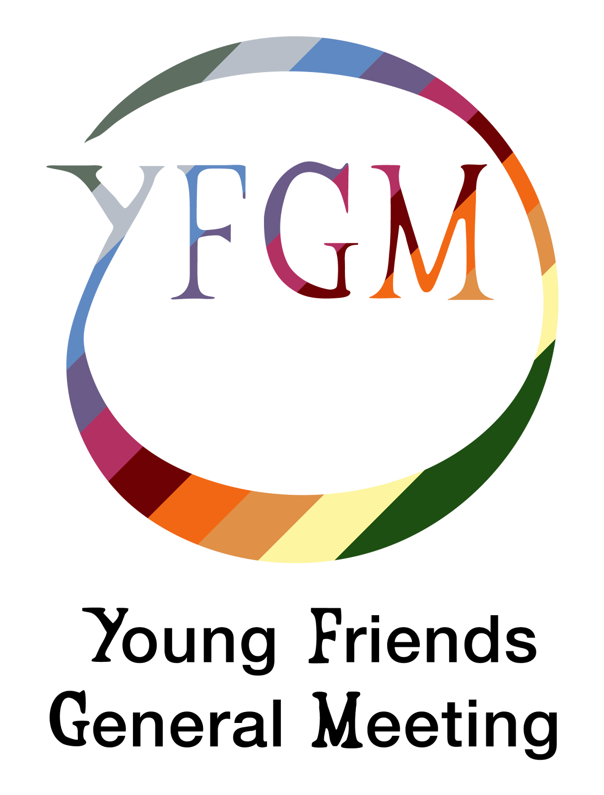  ANNUAL REPORT, INCLUDING FINANCIAL STATEMENTS FOR THE YEAR ENDED DECEMBER 2023 | Charity Number: 1064763  .

Contents
Contents 1
Aims and Purposes of the Charity 2
Objectives and Activities 2
Structure, Governance and Management 3
Collective Decision-Making 3
Roles and Appointment Process 3
Trustees 3
Achievements and performances 4
Gatherings 4
Special Interest Groups 5
Trustee Reforms 6
Publicly Living Our Values 6
Financial Review 7
Declarations 7
Financial Accounts 8

Aims and Purposes of the Charity
Young Friends General Meeting (YFGM) is a registered charity which provides a national community to young adults (individuals of 18 to 35 years of age) who are members or attenders of the Religious Society of Friends (Quakers) or individuals who are interested in the principles and practices of Quakers.
The overall aim of YFGM is the advancement of religion in accordance with the principles and practices of the Quakers. As part of this work, we seek to advance any corporate concerns adopted by our meeting, and charitable objectives, as defined by the charity commission, undertaken at the discretion of the meeting.
Through a shared life and worship YFGM seeks to give our members and attenders a space to explore and develop our faith, and our ways of living out the principles and testimonies of Quakerism in practice; equality, peace, simplicity and integrity.

Objectives and Activities
The principal objective of Young Friends General Meeting is "The advancement of religion in accordance with the principles and practices of the Religious Society of Friends, commonly called Quakers".
The primary activity of YFGM is the running of three residential weekends a year, predominantly within Quaker meeting houses around the UK. In these meetings, attenders gather to worship together, attend sessions led by external speakers and special interest sessions, discuss and work on concerns that members hold, develop their spirituality, talk about their experience of the divine, socialise and build community and attend the business sessions. The business meetings keep the General Meeting running and allow it to serve its function as a representative body within Britain Yearly Meeting, the overarching organisation of the Religious Society of Friends in Great Britain.
Special interest meetings and more informal gatherings supplement these residential meetings. Through the activities of the General Meeting, our members help one another to deepen their understanding of Quakerism, and to live out the Quaker testimonies of equality, simplicity, integrity and peace. When planning our activities, the trustees maintain a level of oversight to ensure public benefit is considered, in line with the Commission’s guidance on the benefit created by charities for the advancement of religion.

Structure, Governance and Management

Collective Decision-Making
As Quakers, the members of YFGM share responsibility for the wellbeing of the community. Major decisions which concern the life and projects of the meeting are undertaken by the General Meeting in accordance with the Quaker Business Method described in Chapter 3 of our church's book of discipline, Quaker Faith and Practice. Young Friends assemble in silence and stillness and seek to discern what the community should do.
We have specific weekends dedicated to the planning of YFGM business meetings, usually six weeks before the relevant general meeting: any member of the community may bring an item of business to a planning weekend for threshing (consideration). YFGM encourages all members to take an active part in meetings for worship for business; the procedure and its spiritual and practical background is talked through, and actively taught, at every general meeting, so that every attender may understand it and take a full part in the process.

Roles and Appointment Process
YFGM functions with the support of its members that serve within roles voluntarily to help achieve the organisation's aims and objectives and support work to hold three residential gatherings a year on behalf of the community.
Current committee areas that members currently serve in include:
- Trustees
- Pastoral
- Elders
- Logistics
- Finance
- Nominations
The process by which members are appointed to roles within each of these committees are in accordance with the principles and practices of the Religious Society of Friends. Appointments to and releases from roles shall be made by minute of the General Meeting. The charity in general meeting shall appoint a Nominations Committee. The Nominations Committee shall be responsible for bringing forward nominations to appointments due to be made by the General Meeting. The members at a general meeting need not accept the nomination made by the Nominations Committee, but may make any appointment they deem fit.

Trustees
Trustees are appointed by YFGM to maintain a strategic vision for YFGM and ensure that YFGM comply with relevant legal obligations, reporting duties to the Charity Commission of England and Wales, and is acting within YFGM’s constitution.
Their work can include period review of policies to ensure legal compliance, signing off policies and budget to be presented to the Meeting, representing the charity to Britain Yearly Meeting and other charity bodies. Trustees can also convene in emergencies of the Meeting where there is no policy in place, and make decisions on behalf of YFGM that may need to be made between general meetings.
Trustees are appointed via a process in accordance with the principles and practices of the Religious Society of Friends as detailed in the “roles and appointment process” section of this report, found above.

As of 19th of May 2024 the trustees are:

- Convenor of Trustees (chair): Leilani Rabemananjara appt. February 2022, expected release May 2025
- Finance Trustee: Liam Lawson - appt. October 2023, expected release February 2027
- Kevin McNamara - appt. October 2023, expected release February 2027
- Georgia Campbell - appt. February 2023, expected release May 2026
- Bel Ingham - appt. May 2023, expected release October 2026

The following trustees served within the reporting period (1st January 2023 to 31st December 2023):

- Tim Hall Farthing,
- Jenny Herbert,
- Leilani Rabemananjara,
- Tim Rouse,
- Hannah Stranex,
- Gray Wood,
- Sammy Gilbert,
- Row Bashforth,
- Liam Lawson,
- Kevin McNamara,
- Bel Ingham

Achievements and performances

Gatherings

In 2023 YFGM held three gatherings, all of which were in person. All planning weekends were held in person which was a first since the onset of the pandemic. The first gathering was held in Brighton and was attended by 47 people. At this general meeting we affirmed the decision of our co-clerks to decline giving a loyal address to Charles Mountbatten-Windsor as a decision had to be made before YFGM met again. In our business meetings we discussed reforms to lower the number of trustees needed to aid with the filling of roles in the face of the struggles of the pandemic and the creation of a “Switchboard” committee which pulls its membership from across the committees of YFGM.

At the end of May we held an in person YFGM in the glorious sun at Bristol Redlands Meeting House which was attended by 45 people. There were discussions around membership which were prompted by a call from Meeting for Sufferings the previous year. We also began to consider ways in which we could commemorate the life of our Friend Naomi Haigh and moved towards the early stages of planning a gathering for our community to celebrate and commemorate her life. Outside of Business Meetings, Friends enjoyed walks around the local park and singing together in the Meeting Hall.

In October we held our final gathering of the year in Lancaster and this saw a rise in people attending with 57 people gathered together, despite transport issues caused by storm Babette. We heard reports from our committees including the presentation of the Annual Report and Accounts, which were presented by Trustees. Prompted by considering our accounts, we began to consider ways in which we can better use the money that we currently have in our accounts. Greater administrative support, funds for outreach and training opportunities were raised as areas where we could consider increasing our spending. A variety of Special Interest Groups were held and the Big SIG was Challenging Transphobia in Quaker Spaces.

Special Interest Groups

YFGM continues to celebrate our member’s voluntary contributions to special interest group activities which run during our gatherings. In 2023 these included twenty which were formally recorded including the following:

- Discussing our approach to racism - Hannah Stranex
- Discussing our approach to transphobia - Hannah Stranex
- YFGM Tea Club - Tim Hall Farthing
- Bringing back YFGM on the road (sharing our processes with Local Meetings) - Tim Hall Farthing
- What do we want to see on the Yearly Meeting agenda? - Rachael Booth
- Dance - Rowan Queerly (at two separate YFGM gatherings)
- Intro to British Sign Language - Will Reed
- Feminist Gospels: Mary Magdalene - Jennie Atherton
- Designing YFGM Tea-towels - Becky Shirley
- Singing - Jenny Baines
- Repair Café - Gray Wood
- Jesus Prayer - Jaz Higgs
- Welcome Pack - Dan Dickson & Ceridwen Jenkins
- Challenging Transphobia in Quaker Spaces - Chloe Scaling and others
- Quaker Socialism - Lawrence Hall
- Getting in the Sea - Jenny Baines
- Moravian Side-wound Theology - Sasha Lawson-Frost
- Godless Quakerism - Lawrence Hall
- Responding to call for discernment on Membership - Tim Rouse

Trustee Reforms

2023 saw YFGM undergo significant reform to our Trustee body and the establishing of a ‘Switchboard’ committee. This reduced the size of our trustee body, focusing it on governance, with the new ‘Switchboard’ committee having representation from committees across YFGM. We were joyful and excited about adopting this model, hoping that it will bring flexibility within trustees and in the interactions between committees.

Publicly Living Our Values

In 2023 our co-clerk Hannah Stranex reported to the community on an invitation received by clerks in early February, to send two people from YFGM to be part of a Quaker delegation to give a loyal address to Charles Mountbatten-Windsor, called King, on 9 March. Quakers in Britain have historically been a privileged body, invited to make such addresses at significant times in the life of the monarch. Around thirty such privileged bodies exist. Quakers in Britain received this invitation without sufficient time that there was not the opportunity for discernment on the invitation by Meeting for Sufferings who were set to send a delegation. YFGM was invited as a General Meeting within the Yearly Meeting, and to provide representation for young people among the delegation. Facing a deadline to give a response that fell before YFGM, and after discussion with some YFGMers, clerks declined the invitation, giving the following explanation to Britain Yearly Meeting staff: “As this could not go to the General Meeting for discernment in time, the clerks have taken the decision after consulting with a range of YFGMers. We heard - and had - objections including that participating legitimises an institution at odds with Quaker values, that making a 'loyal' address would not be truthful, and that our presence would be tokenistic rather than following the movement of the Spirit. In the circumstances, we feel that YFGM could not in good conscience accept this invitation without the opportunity for full discernment. We're glad to hear that the planned text will include clear calls for full social and legal equality for trans people, and for the dismantling of racialised privilege throughout society. We hope that in "speaking truth to power", the address focuses on truth without the cushioning of unearned honour or false flattery.” The gathering, and community of YFGM, thanked clerks stating that they supported and upheld clerks' decision which was captured formally within the minutes of a YFGM gathering for making this decision in difficult circumstances on the community’s behalf and that it reflected the feeling of the meeting well.

Further to this part of minute 2023.02.6.b, captured on behalf of the community, read “...Christ taught that “It is easier for a camel to go through the eye of a needle, than for a rich man to enter into the kingdom of God.” Both the riches of the monarch and their claim to dominion over the rest of us are intrinsic to the institution of the monarchy; such an institution is incompatible with our testimony to the equality of all. Quakers have a long tradition of speaking truth to those who hold power, however deserved that power; but if we are truly being led to speak truth to power then our words and our actions will be illuminated by the living spirit. The rising tide of authentic ministry is undeniable, we quake and shake with it; is this what we are doing when we give a carefully curated loyal address, however nicely worded? The raw unfiltered leadings of the spirit leave no room for curation or royal approval. Our words must be chosen not for their appeal, nor even for how we as individuals agree with their sentiment, but for whether they express the spirit as it moves among the seekers of the light, the friends of truth that we aspire to be. We hope that there is a path for further discussion within British Quakerism regarding both attitudes to the monarchy, and what it means to speak truth to the institutions of power and privilege in this day and age…”

Financial Review

YFGM is pleased to report a net income of £3,212 for 2023. While this represents a decrease from previous years due to increased expenditures, it's important to remember the context. 2023 marked a significant year for our community. For the first time since the pandemic, we were able to hold all three of our signature YFGM gatherings and planning weekends in person. These in-person events, which are vital for fostering connections and shared experiences among young Friends, naturally come with higher costs compared to virtual gatherings.

YFGM is committed to responsible financial stewardship. We are grateful for the continued support of our members and Friends, whose generous donations helped maintain a steady level of income throughout the year. Additionally, the appointment of a new fundraiser in October 2023 positions us for even stronger financial growth in the coming years. The new fundraiser's expertise will be instrumental in diversifying our funding streams, potentially reducing reliance on individual donations and ensuring a sustainable future for YFGM events and SIGs.

YFGM is fortunate to have healthy reserves of £95,723, with £18,655 designated for restricted purposes. This strong financial position allows us to look towards the future with confidence. Guided by Quaker principles of discernment and care for the community, the trustees are committed to using these surplus funds thoughtfully and for the enduring benefit of young Friends.

Declarations
The trustees declare that they have approved the trustees’ annual report above.
Signed on behalf of the charity’s trustees:
Signature: 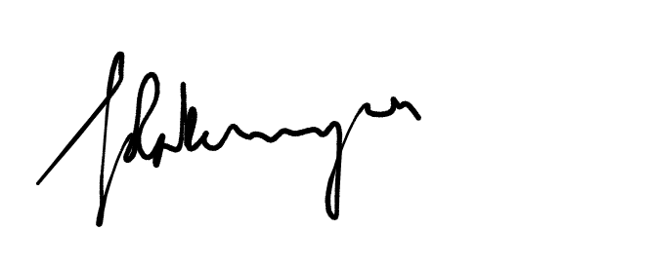
Full Name: Leilani Rabemananjara
Position: Convenor of Trustees / Charity Commission Contact Date: 23/05/24

Financial Accounts

Notes to the Financial Statements
Statutory Information
Young Friends General Meeting of the Religious Society of Friends (Quakers), commonly known as Young Friends General Meeting or YFGM, is an unincorporated charity registered with the Charity Commission for England and Wales as charity no. 1064763
The registered office address is YFGM Office, Friends House, 173 Euston Road, London NW1 2BJ.
Note 1. Accounting Policies
1.1 Basis of accounting
Young Friends General Meeting constitutes a public benefit entity as defined by FRS102.
These accounts have been prepared under the historical cost convention with items recognised at cost or transaction value unless otherwise stated in the relevant note(s) to these accounts.
"The accounts have been prepared in accordance with the Statement of Recommended Practice: Accounting and Reporting by Charities preparing their accounts in accordance with the Financial Reporting Standard applicable in the UK and Republic of Ireland (FRS 102), and with the Financial Reporting Standard applicable in the United Kingdom and Republic of Ireland (FRS 102) and with the Charities Act 2011."
1.2 Going concern
These accounts have been prepared on the going concern basis. The trustees consider that, in view of the charity's significant cash reserves and forecasts for the next twelve months, there are no material uncertainties as to the charity's ability to continue as a going concern.
1.3 Changes of accounting policy and estimates
In previous periods, the charity has made additional disclosures beyond those required by the SORP, relating to reimbursement of expenses to trustees and closely connected persons. Due to the low number of claims this year, these additional disclosures have been omitted this year to prevent the disclosure of amounts paid to individuals.

1.4 Income
Income is recognised in the Statement of Financial Activities (SoFA) in the period in which the charity is entitled to receipt; it is more likely than not to be received; and where the amount can be measured with reasonable certainty.
There has been no offsetting of assets and liabilities, or income and expenses, unless required or permitted by the FRS102 SORP or FRS102.
The charity has received no government grants during the reporting period, or in the prior reporting period.
The value of voluntary help received is not included in the accounts but is described in the trustees' annual report.
1.5 Expenditure
Liabilities are recognised where it is more likely than not that there is a legal or constructive obligation committing the charity to pay out resources and the amount of the obligation can be measured with reasonable certainty.
Expenditure is included in the statement of financial activities when incurred and is inclusive of VAT.
1.6 Assets
Tangible fixed assets for use by the charity are capitalised if they can be used for more than one year, and cost at least £500. They are valued at cost and depreciated on a straight-line basis over their estimated useful economic life.
The charity does not at present hold investments.
The charity does not at present hold stocks held for sale.
Stocks held for distribution as part of charitable activities are recognised where the value of the line of stock at purchase exceeds £500, and are measured at net realisable value based on the service potential provided by items of stock.
Debtors (including trade debtors and loans receivable) are measured on initial recognition at settlement amount. Subsequently, they are measured at the cash or other consideration expected to be received.

